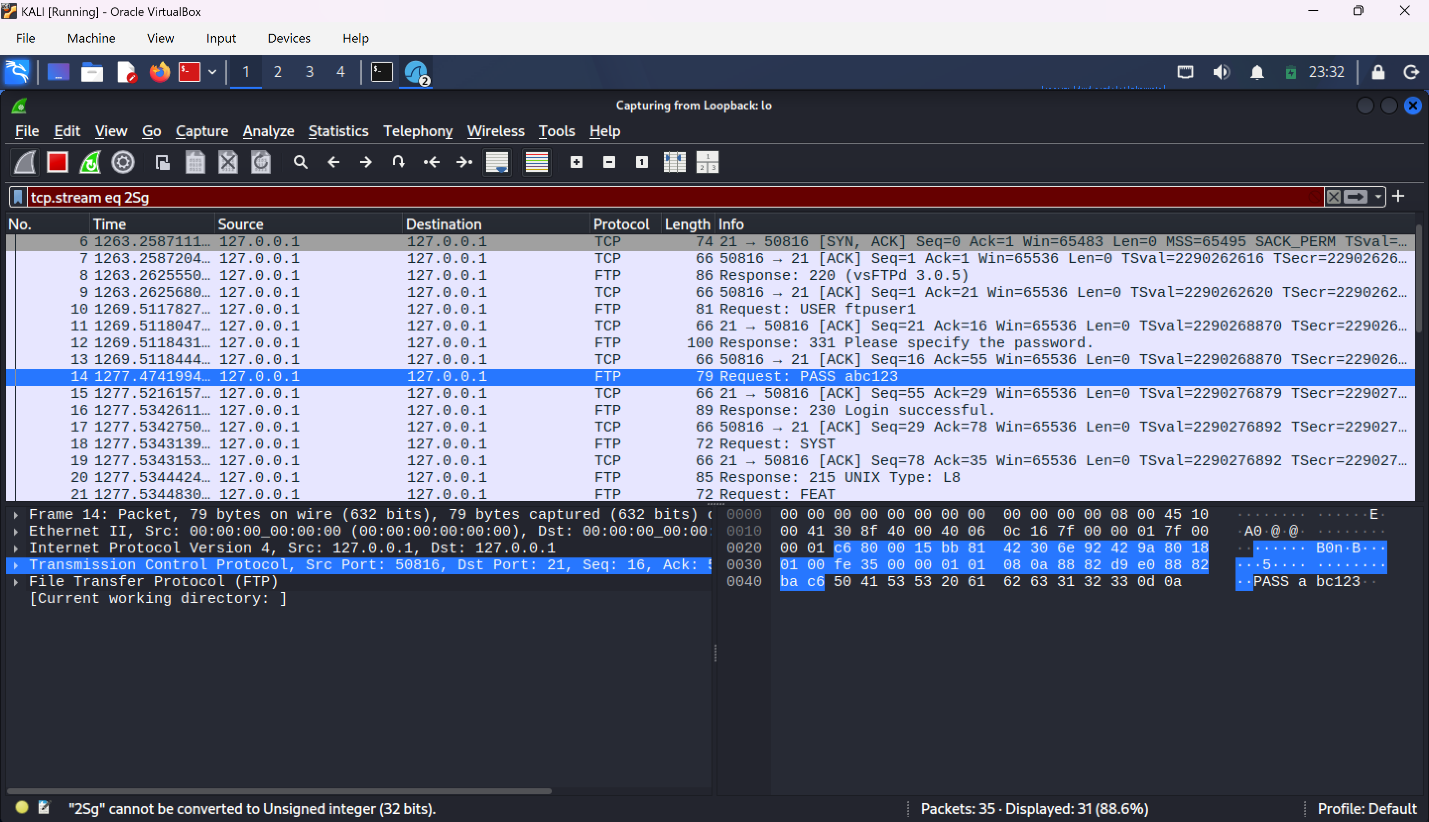
FTP SERVER CAPTURES IN WIRESHARK INCL PORT DETAILS

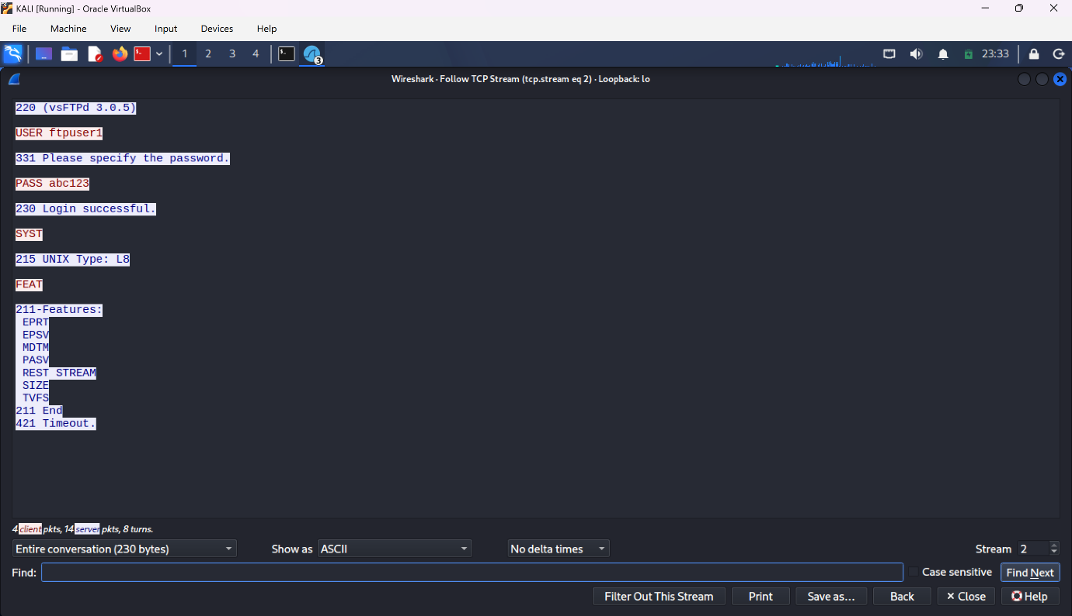
USER CREDENTIALS

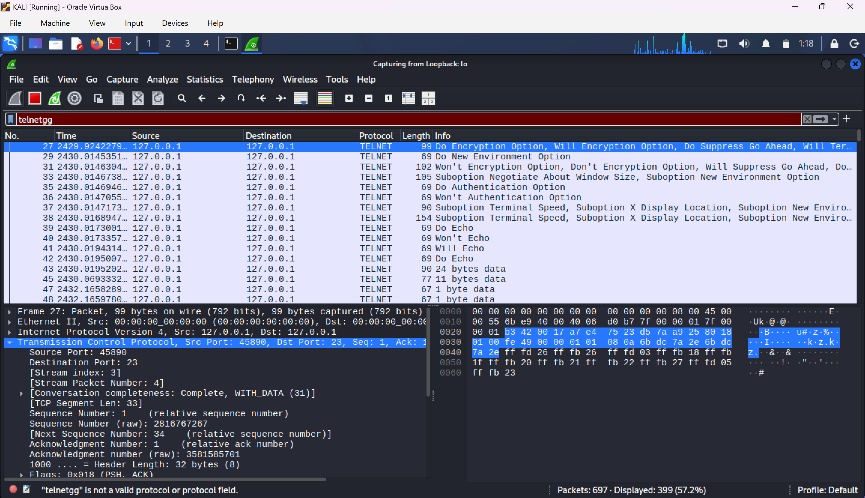
TELNET INCL PORT DETAILS

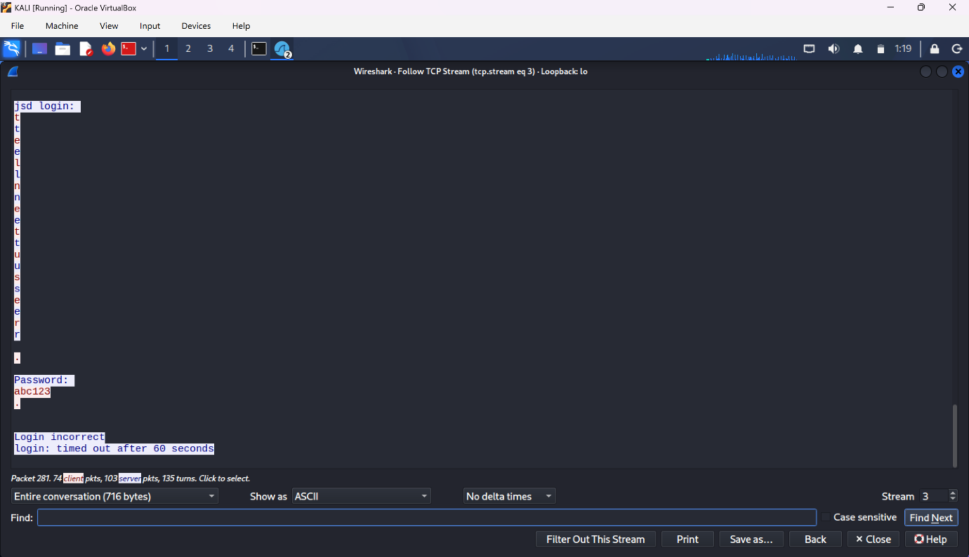USER CREDENTIALS

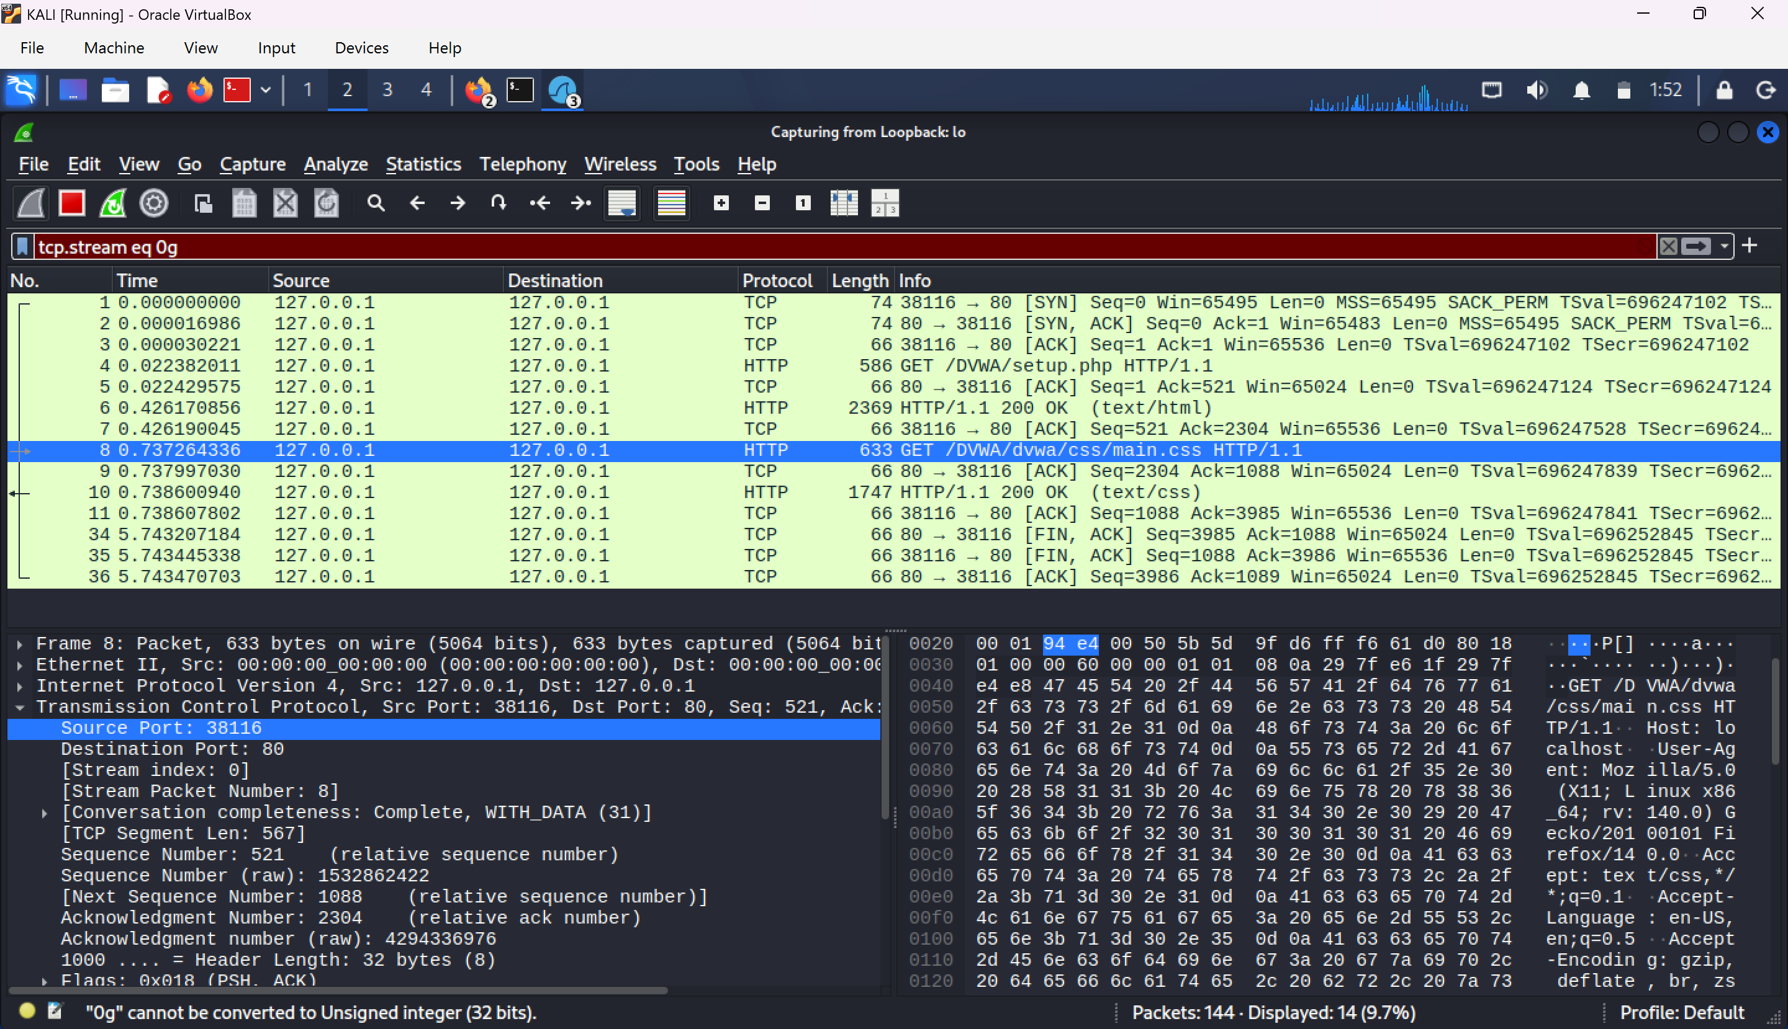
DVWA (INCL PORT DETAILS OF HTTP)

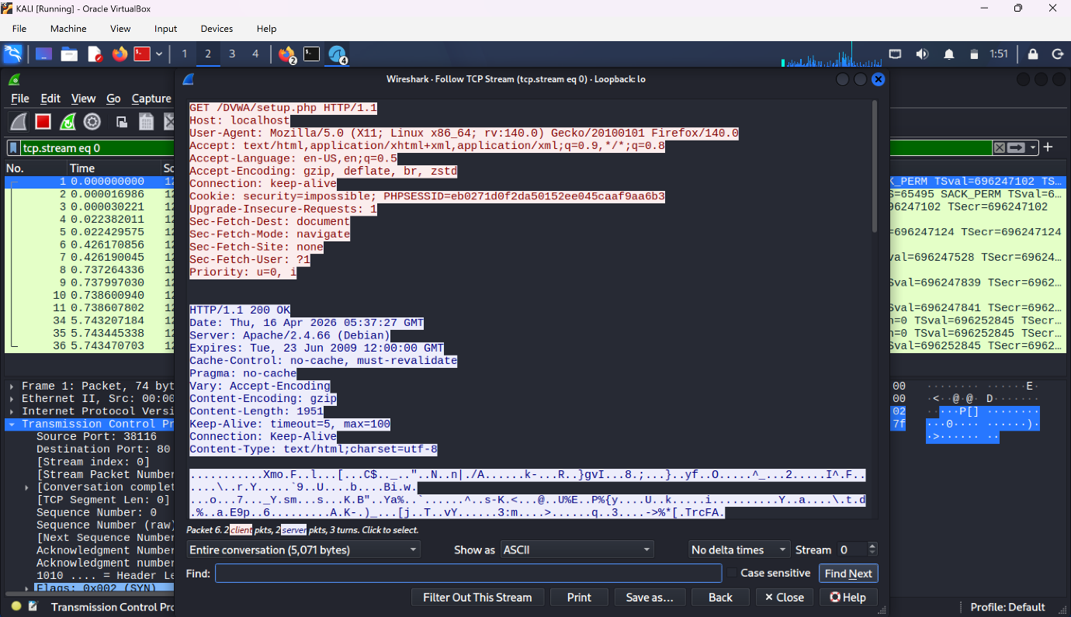
USER CREDENTIALS WHILE USING DVWA

Why absence of encryption is dangerous?

- Risk of Evasdropping (Sniffing)
- Man in the Middle (MITM) Attacks vulnerability.
- Data Breach Impact.
- Lack of integrity verification.
- Identity theft and spoofing.
- Vulnerability in Muti domain operations.
- Regulatory and legal non compliance.

